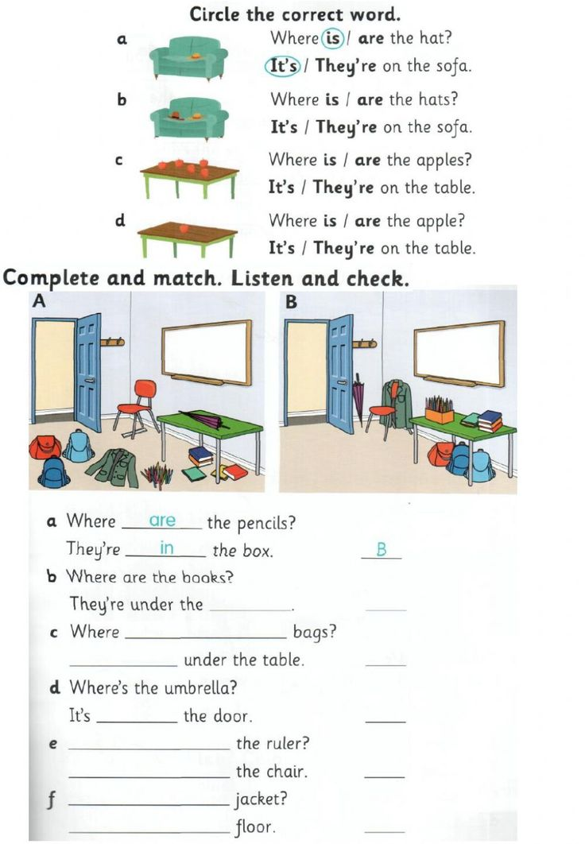
Evaluation process Level : 6th Discipline : Foreign Language

